**RRJETAT E KOMPJUTERAVE 1**

**LAB 6-7**

**Tema:** Konfigurimi i nje Topologjie Rrjeti duke perdorur Link State Routing protocol

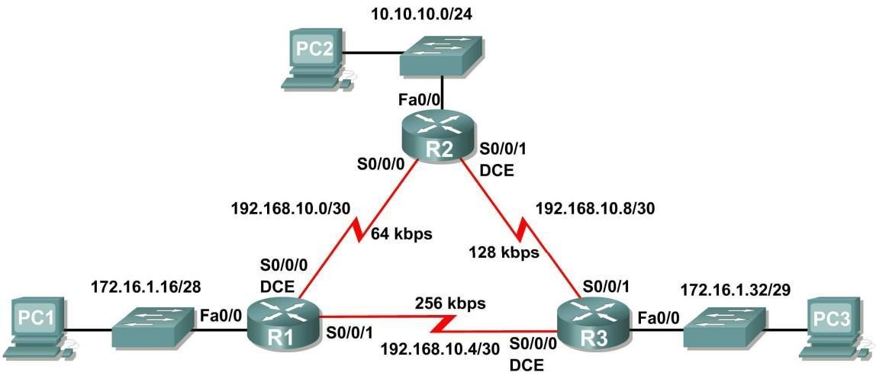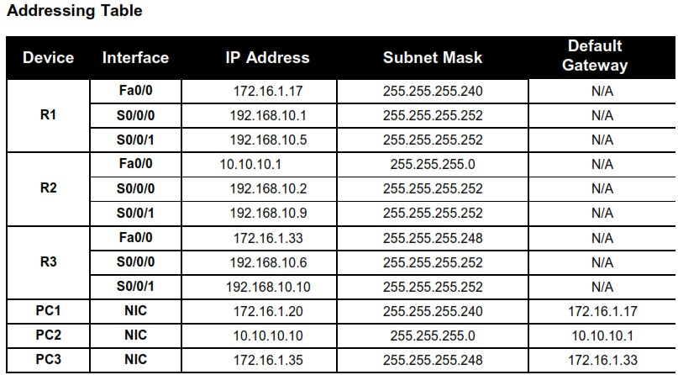

**Step 1:** Configure the routers

On the routers, enter global configuration mode and configure the hostname as shown on the chart. Then configure the console, virtual terminal lines password (both “cisco”) and privileged EXEC password (“class”):

**Step 2:** Disable DNS lookup

Router(config)#no ip domain-lookup

**Step 3:** Configure the interfaces on R1, R2, and R3

Configure the interfaces on the R1, R2, and R3 routers with the IP addresses from the table under the Topology Diagram.

**Step 4:** Verify IP addressing and interfaces

Use the show ip interface brief command to verify that the IP addressing is correct and that the interfaces are active.

**Step 5:** Configure Ethernet interfaces of PC1, PC2, and PC3

Configure the Ethernet interfaces of PC1, PC2, and PC3 with the IP addresses and default gateways from the table under the Topology Diagram.

# Task: Configure OSPF on the R1 Router

**Step 1:** Use the router ospf command in global configuration mode to enable OSPF on the R1 router. Enter a process ID of 1 for the *process-ID* parameter.

R1(config)#router ospf 1

R1(config-router)#

**Step 2:** Configure the network statement for the LAN network.

Once you are in the Router OSPF configuration sub-mode, configure the LAN network 172.16.1.16/28 to be included in the OSPF updates that are sent out of R1.

The OSPF network command uses a combination of *network-address* and *wildcard-mask* similar to that which can be used by EIGRP. Unlike EIGRP, the wildcard mask in OSPF is required.

Use an area ID of 0 for the OSPF *area-id* parameter. 0 will be used for the OSPF area ID in all of the network statements in this topology.

R1(config-router)#network 172.16.1.16 0.0.0.15 area 0

R1(config-router)#

**Step 3**: Configure the router to advertise the 192.168.10.0/30 network attached to the Serial0/0/0 interface.

R1(config-router)# network 192.168.10.0 0.0.0.3 area 0

R1(config-router)#

**Step 4:** Configure the router to advertise the 192.168.10.4/30 network attached to the Serial0/0/1 interface.

R1(config-router)# network 192.168.10.4 0.0.0.3 area 0

R1(config-router)#

**Step 5:** When you are finished with the OSPF configuration for R1, return to privileged EXEC mode.

R1(config-router)#end

%SYS-5-CONFIG_I: Configured from console by console R1#

# Task: Configure OSPF on the R2 and R3 Routers

**Step 1**: Enable OSPF routing on the R2 router using the router ospf command. Use a process ID of 1.

R2(config)#router ospf 1

R2(config-router)#

**Step 2**: Configure the router to advertise the LAN network 10.10.10.0/24 in the OSPF updates.

R2(config-router)#network 10.10.10.0 0.0.0.255 area 0

R2(config-router)#

**Step 3:** Configure the router to advertise the 192.168.10.0/30 network attached to the Serial0/0/0 interface.

R2(config-router)#network 192.168.10.0 0.0.0.3 area 0

R2(config-router)#

00:07:27: %OSPF-5-ADJCHG: Process 1, Nbr 192.168.10.5 on Serial0/0/0 from EXCHANGE to FULL, Exchange Done

Notice that when the network for the serial link from R1 to R2 is added to the OSPF configuration, the router sends a notification message to the console stating that a neighbor relationship with another OSPF router has been established.

**Step 4:** Configure the router to advertise the 192.168.10.8/30 network attached to the Serial0/0/1 interface.

When you are finished, return to privileged EXEC mode.

R2(config-router)#network 192.168.10.8 0.0.0.3 area 0

R2(config-router)#end

%SYS-5-CONFIG_I: Configured from console by console R2#

**Step 5:** Configure OSPF on the R3 router using the router ospf and network commands.

Use a process ID of 1. Configure the router to advertise the three directly connected networks. When you are finished, return to privileged EXEC mode.

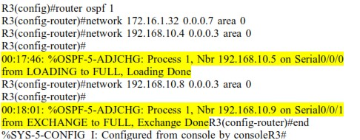

Notice that when the networks for the serial links from R3 to R1 and R3 to R2 are added to the OSPF configuration, the router sends a notification message to the console stating that a neighbor relationship with another OSPF router has been established.

# Task: Configure OSPF Router IDs

The OSPF router ID is used to uniquely identify the router in the OSPF routing domain. A router ID is an IP address. Cisco routers derive the Router ID in one of three ways and with the following precedence:

IP address configured with the OSPF router-id command.

Highest IP address of any of the router’s loopback addresses. Highest active IP address on any of the router’s physical interfaces.

**Step 1:** Examine the current router IDs in the topology.

Since no router IDs or loopback interfaces have been configured on the three routers, the router ID for each router is determined by the highest IP address of any active interface.

What is the router ID for R1?

What is the router ID for R2?

What is the router ID for R3?

The router ID can also be seen in the output of the show ip protocols, show ip ospf, and show ip ospf interfaces commands.

**R3#**show ip protocols

Routing Protocol is "ospf 1"

Outgoing update filter list for all interfaces is not set Incoming update filter list for all interfaces is not set

Router ID 192.168.10.10

Number of areas in this router is 1. 1 normal 0 stub 0 nssa Maximum path: 4 *<output omitted>*

**R3#**show ip ospf

Routing Process "ospf 1" with ID 192.168.10.10 Supports only single

TOS(TOS0) routes

Supports opaque LSA

SPF schedule delay 5 secs, Hold time between two SPFs 10 secs

*<output omitted>*

**R3#**show ip ospf interface

FastEthernet0/0 is up, line protocol is up Internet address is 172.16.1.33/29, Area 0

Process ID 1, Router ID 192.168.10.10, Network Type BROADCAST, Cost:

1

Transmit Delay is 1 sec, State DR, Priority 1

Designated Router (ID) 192.168.10.10, Interface address 172.16.1.33 No backup designated router on this network

Timer intervals configured, Hello 10, Dead 40, Wait 40, Retransmit 5 Hello due in 00:00:00

Index 1/1, flood queue length 0 Next 0x0(0)/0x0(0)

Last flood scan length is 1, maximum is 1

Last flood scan time is 0 msec, maximum is 0 msec Neighbor Count is 0, Adjacent neighbor count is 0

Suppress hello for 0 neighbor(s)

*<output omitted>*

R3#

**Step 2:** Use loopback addresses to change the router IDs of the routers in the topology.

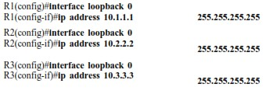

**Step 3:** Reload the routers to force the new Router IDs to be used.

When a new Router ID is configured, it will not be used until the OSPF process is restarted. Make sure that the current configuration is saved to NRAM, and then use the reload command to restart each of the routers.

When the router is reloaded, what is the router ID for R1?

When the router is reloaded, what is the router ID for R2? When the router is reloaded, what is the router ID for R3?

**Step 4:** Use the show ip ospf neighbors command to verify that the router IDs have changed.

R1#show ip ospf neighbor

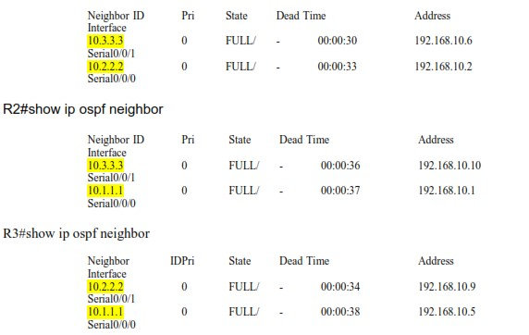

**Step 5:** Use the router-id command to change the router ID on the R1 router.

Note: Some IOS versions do not support the router-id command. If this command is not available, continue to the next Task.

R1(config)#router ospf 1

R1(config-router)#router-id 10.4.4.4

Reload or use “clear ip ospf process” command, for this to take effect

If this command is used on an OSPF router process which is already active (has neighbors), the new router-ID is used at the next reload or at a manual OSPF process restart. To manually restart the OSPF process, use the clear ip ospf process command.

R1#(config-router)#end R1# clear ip ospf process

Reset ALL OSPF processes? [no]:yes R1#

**Step 6:** Use the show ip ospf neighbor command on router R2 to verify that the router ID of R1 has been changed.

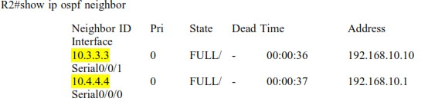

**Step 7:** Remove the configured router ID with the no form of the router-id command.

R1(config)#router ospf 1

R1(config-router)#router-id 10.4.4.4

Reload or use “clear ip ospf process” command, for this to take effect

**Step 8:** Restart the OSPF process using the clear ip ospf process command.

Restarting the OSPF process forces the router to use the IP address configured on the Loopback 0 interface as the Router ID.

R1(config-router)#end R1# clear ip ospf process

Reset ALL OSPF processes? [no]:yes R1#

**Task:** **Verify OSPF Operation.**

**Step 1:** On the R1 router, Use the show ip ospf neighbor command to view the information about the OSPF neighbor routers R2 and R3. You should be able to see the neighbor ID and IP address of each adjacent router, and the interface that R1 uses to reach that OSPF neighbor.

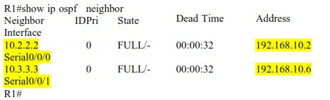

**Step 2:** On the R1 router, use the show ip protocols command to view information about the routing protocol operation.

Notice that the information that was configured in the previous Tasks, such as protocol, process ID, neighbor ID, and networks, is shown in the output. The IP addresses of the adjacent neighbors are also shown.

**R1#**show ip protocols

Routing Protocol is "ospf 1"

Outgoing update filter list for all interfaces is not set Incoming update filter list for all interfaces is not set

Router ID 10.1.1.1

Number of areas in this router is 1. 1 normal 0 stub 0 nssa Maximum path: 4

Routing for Networks: 172.16.1.16 0.0.0.15 area 0

192.168.10.0 0.0.0.3 area 0 192.168.10.4 0.0.0.3 area 0 Routing Information Sources:

Gateway Distance Last Update

10.2.2.2 110 00:11:43

10.3.3.3 110 00:11:43

Distance: (default is 110) R1#

Notice that the output specifies the process ID used by OSPF. Remember, the process ID must be the same on all routers for OSPF to establish neighbor adjacencies and share routing information.

# Task: Examine OSPF Routes in the Routing Tables

View the routing table on the R1 router. OSPF routes are denoted in the routing table with an “O”.

**R1#**show ip route

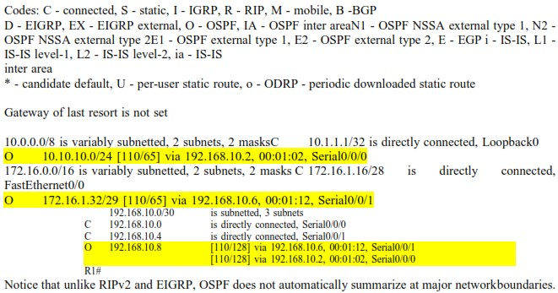

Step 1:

Kryejmë konfigurimin sipas kërkesës

Konfigurimi I R1 , po ashtu dhe për R2 dhe R3.

Paraqitja e re e CLI.

Step 2:

Step 3,4,5:

Kryejmë një ping nga default gateway i PC3 dhe shoim qe rrjeti punon

Skema e ndërtuar

Task: Configure OSPF on the R1 Router

Task: Configure OSPF on the R2 and R3 Routers

Task: Configure OSPF Router IDs

Step 1:

* What is the router ID for R1? Router ID 192.168.10.5
* What is the router ID for R2? Router ID 192.168.10.9
* What is the router ID for R3? Router ID 192.168.10.10

Step 2:

Step 3:

* When the router is reloaded, what is the router ID for R1? Router ID 10.1.1.1
* When the router is reloaded, what is the router ID for R2? Router ID 10.2.2.2
* When the router is reloaded, what is the router ID for R3? Router ID 10.3.3.3

Step 4:

Step 5:

Step 6:

Step 7:

Step 8:

Task: Verify OSPF Operation.

Step 1:

Step 2:

Task: Examine OSPF Routes in the Routing Tables

